Container ships

With globalization, outsourcing and offshoring and increased trade the volume of goods transported around the globe has increased enormously – and container ships play a crucial role in this business.

The aim of this report is to inform about major facts about seaborne trade from 1980 to 2017. The report will also inform about the pros & cons, accidents of container ships, the role of the Panama Canal and the biggest Chinese port.

Containership capacity is measured in TEU (“Twenty Foot Equivalent Unit”) which is the same as one times 20 feet long container.

As indicated in the chart below, the capacity of container ships in seaborne trade has increased significantly from 1980 to 2017 in million dwt. Dwt is the deadweight tonnage. It is a measure of how much weight a ship can carry.

As you can see the number of million dwt has almost doubled from 2005 to 2010. In the last three years that growth slowed down.

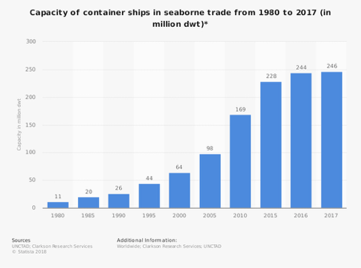

**How much cargo can the largest shipping container ship really hold?**

It is remarkable that in an age of flight and space travel, most cargo transport around the world is still done by sea. Because of the increasing demands of global trade, cargo ships receive more and more cargo capacity.

The earliest container ships typically had a capacity of a few hundred TEU, meaning they could hold about a hundred 20-foot cargo containers. By the late 1960s, the first 1000 TEU capacity container ships were built.

The current capacity of the largest container ships is over 20.000 TEU. And the companies that build these ships intend to make them even larger. The largest ship currently is the OOCL Hong Kong. It has a capacity of 21.413 TEU.

**Panama Canal**

The Panama Canal is an artificial 82 km waterway in Panama. It connects the Atlantic Ocean with the Pacific Ocean.

Around 14.500 vessels pass through the Panama Canal each year. And ships worldwide have been built with the dimensions of the canal’s original locks. There are three lanes of locks.

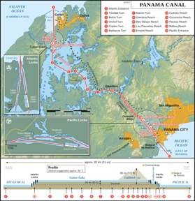

**Biggest port in the world**

The biggest port in the world is the port of Shanghai, it handled 40 million TEUs in 2017.

The port is located at the mouth of the Yangtze River covering an area of 3.619 square kilometers.

The port comprises of 125 berths with a total quay length of about 20 km. It serves more than 2.000 container ships on a monthly basis and accounts for a quarter of China’s total foreign trade.

**Accidents**

Despite the large number of containers shipped, accidents are relatively rare. Less than 1.500 containers are lost from ships each year on average.

But accidents do happen, and when they do, they can lead to a disaster.

On 6 March 2018, a container ship (Maersk Honam) was on the Arabian Sea. It was loaded with a total of 7.860 containers. The vessel reported a serious fire in one of its cargo holds. Tragically, five crew members died as a result of the accident. Reports suggest that flames have been contained on board the vessel, the fire at one point was so large that it could be seen from space.

Only recently (on 2 January 2019), one of the world`s largest cargo ships lost 270 containers near a German sland in North Sea. Among the goods being washed ashore on Dutch islands were TV screens, cars, freezers and IKEA furniture.

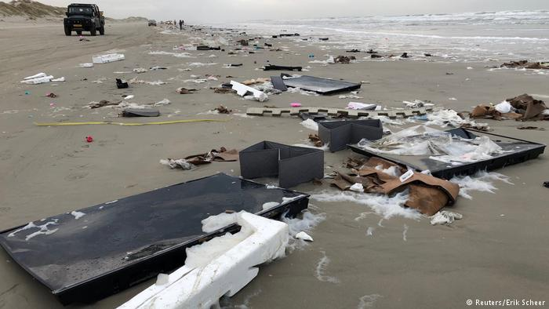

Strong winds caused an unusual accident: 270 containers fell from a cargo ship under Panamanian flag littering Dutch beaches.

